Name: |  | Class:

Scratch 4 Arduino

You will also need the following hardware…

Item | Qty
Laptop | x1
USB Cable | x1
Arduino | x1
Jumper wires | A bunch
LED | x1 set
Resistors | x1 set
Breadboard | x1

As the lessons progress, you will be provided with more hardware, but this is enough to start.

Getting the slides…

- https://a9i.sg/huayi – look for Lesson 2 (S4A) Slides
- Please use the PDF version
(your school laptops don’t carry software that can properly show .ODP files)
Lesson 2 (PWM)
Exercise 2a (Control LED Brightness)

Review LED Circuit
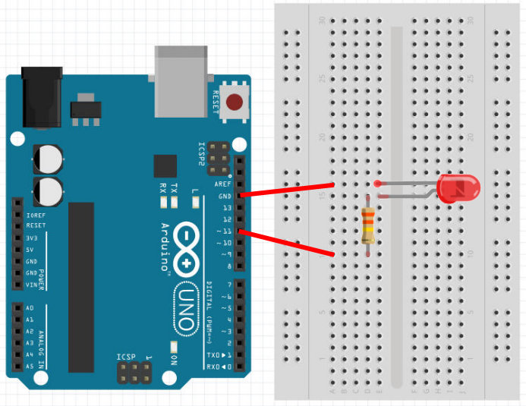
LED
Connect short leg to ground (GND) and long leg to resistor.

Resistor
Use a 330 ohms resistor.
Connect one end to resistor and the other to Pin 11.
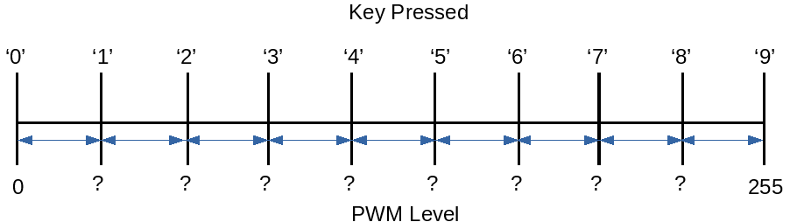
Fill in the correct levels
Try to come up with a general mathematical formula to calculate PWM Levels for N keys?

____________________________
Key | PWM Level |  | Key | PWM Level
0 | 0 |  | 5
1 |  |  | 6
2 |  |  | 7
3 |  |  | 8
4 |  |  | 9 | 255
2a) Add code to control LED brightness levels using all ten digit (0-9) keys

You may be able to generalize the output as the above mathematical function...

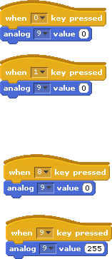

?
?
?
?
?
?
?
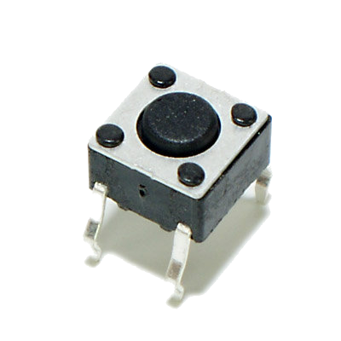
2b)

* Extend the program above to make the dimmer effect go from low to high and back to low again.

* Extend the program to repeat this dim-up-down effect continuously for 10 times.

Extra Challenges

* Convert your variable to a Slider and use it as a graphical Variable Dimmer Switch

* Create a Graphical Dashboard to control Lights
(on/off & blink buttons using sprites, slider dimmers using variables)

* Use a physical button to act as a Toggle Dimmer Switch (on/off)

* Use multiple LEDs to create a Light Show with blinking, dimming, and any other effects you can muster

