Name: |  | Class:

Lesson 3 (Analog Input)

https://a9i.sg/huayi – look for Lesson 3 Slides

Exercise 3a (Read from A0

Connect this Circuit! Make sure to get a Potentiometer...

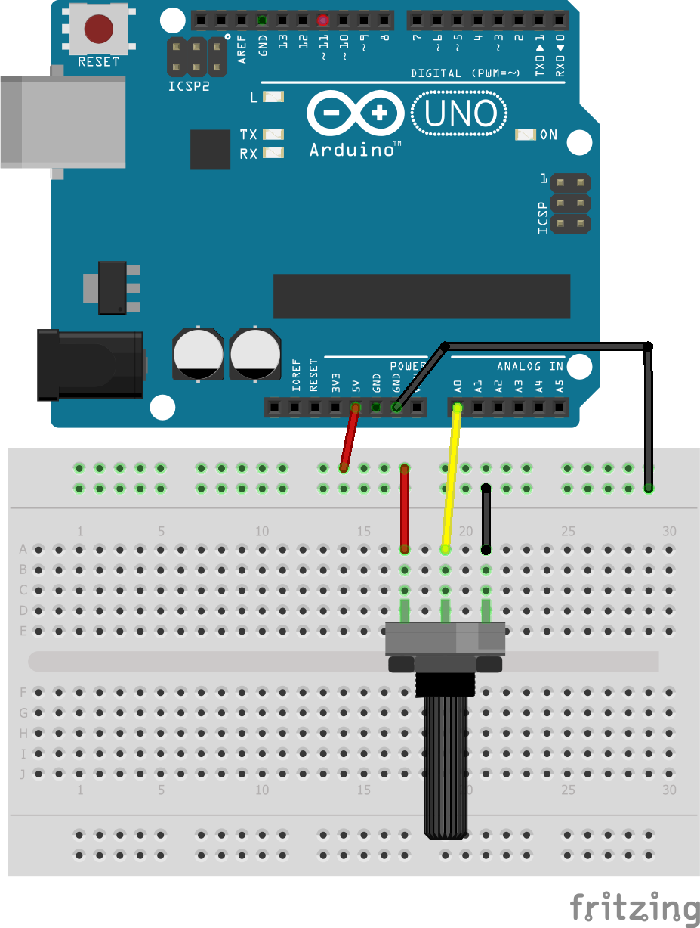
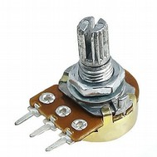

?
GND
5v
A0

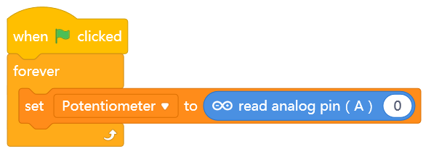
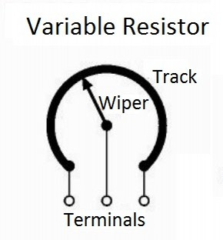
3a)

* What is the range of values you can read from A0?
Min: ________ Max:________

* Extend the program above:
1) checks if Potentiometer wiper is
closer to GND or closer to 5V (A0 > ______ ?)
2) if closer to GND
Panda says “GND”
else
Panda says “5V”

5v
GND
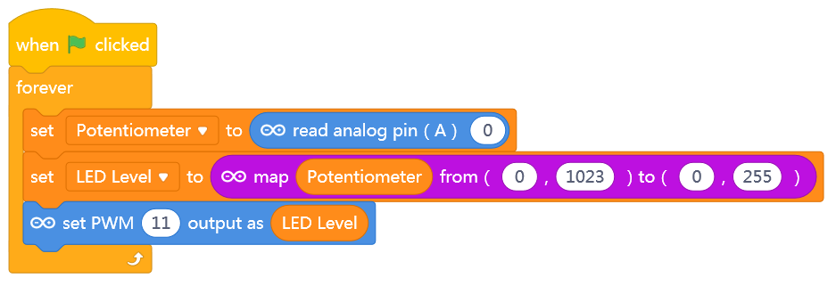
3b)

* Try to Upload the program to the Arduino for a smoother Dimmer Effect.

* Change the program such that the Potentiometer controls how fast the LED blinks, instead of brightness.

For instance:
A0LED
01 blink a second
51225 blinks a second
102350 times a second

Physical Dimmer Switch

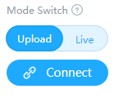
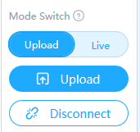

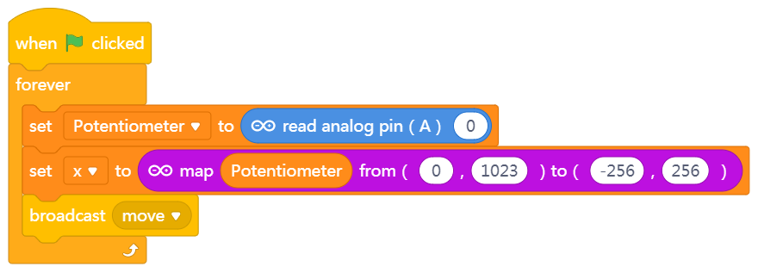


3c) Extend Above Program

* Make Panda point towards the new X

* Make Panda look like it’s walking by changing costumes

* Add a second Potentiometer to control Y.
Like an Etch-a-Sketch!
?
OR
Simple Joystick

