Name: |  | Class:

Scratch + Arduino

Before you start…

Make sure you have the mLink software installed. The icon should look like this…



You will also need the following hardware…

Item | Qty
Laptop | x1
USB Cable | x1
Arduino | x1
Jumper wires | A bunch
LED | x1 set
Resistors | x1 set
Push button switch | x1
Breadboard | x1

As the lessons progress, you will be provided with more hardware, but this is enough to start.

Getting the slides…

Slides for this programme are available at https://a9i.sg/huayi

Your school laptops do not have LibreOffice installed, so please use the PDF version.
Lesson 1 (Outputs / Inputs)

Exercise 1a (External LEDs)

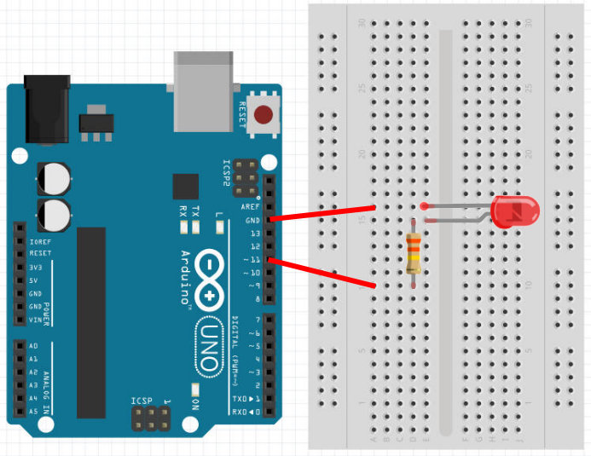
LED
Connect short leg to ground (GND) and long leg to resistor.

Resistor
Use a 330 ohms resistor.
Connect one end to resistor and the other to Pin 11.
Why have a resistor?
- Arduino pins provides 5V
- LEDs requires different voltages depending on color
  - Red, Yellow, Infra-red: 1.8V
  - Blue, White, UV: 3.3V
  - Green: Depends. Try 1.8V first.
- Resistor helps to reduce the voltage

Challenges!

1) Modify your earlier program to control the external LED instead of the internal LED. What changes did you make?

Ans: ____________________________________________________________________

_________________________________________________________________________

2) Program the connected LED blink continuously.
Do this on your computer and inform the instructor when done.
Exercise 1b (External Inputs)

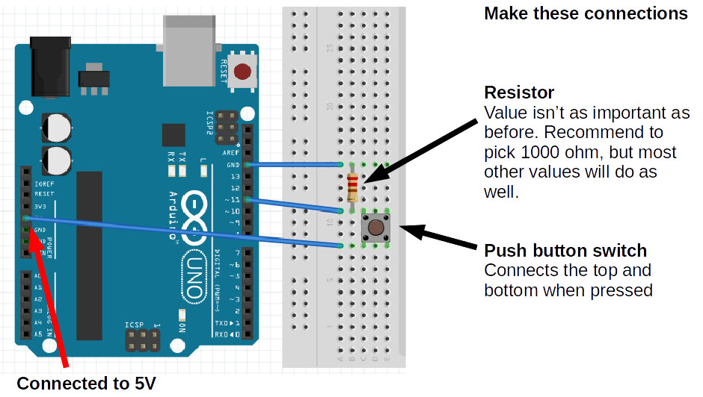
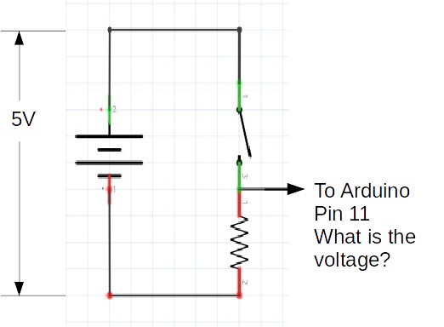
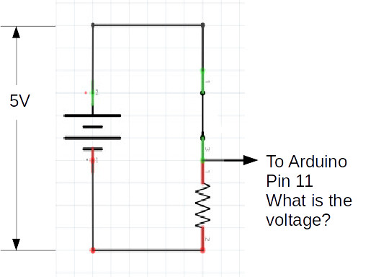
Switch Open  - Pin 11 is connected to 0V via the resistor  - Pin 11 not connected to 5V  - Voltage of pin 11:  = 0 V  = False  = Low | Switch Closed  - Pin 11 is connected to 0V via the resistor  - Pin 11 is connected to 5V directly  - Voltage of pin 11:  = 5 V  = True  = High

Why?

Why can’t we connect the switch directly to ground without a resistor?

Ans: ____________________________________________________________________

_________________________________________________________________________

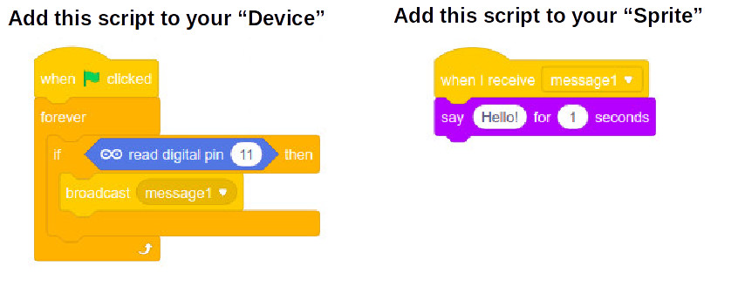

Challenges!

1) Make an LED blink rapidly for 2 seconds when the button is pressed

2) Make an LED toggle between on and off when the button is pressed

Do these on your computer and inform the instructor when done.

