Lesson 5 (PC – Arduino Integration)

Slides – https://a9i.sg/huayi
mBlock – https://ide.mblock.cc (start mLink too!)

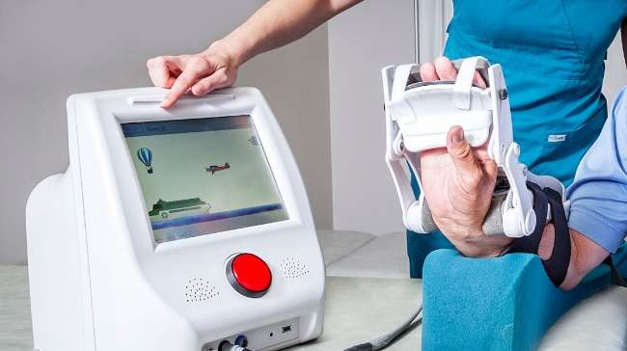
Rehabilitation training for stroke patients
Introduction

The PC and the Arduino are good for different things. By using the strength of each, we can create a better product than what each of them can achieve on its own.

In this lesson, we will build a simple game that integrates with the Arduino.

Advantages

PC | Arduino
- Large display  - Keyboard and mouse  - Sound, graphics, video  - Great for games and animation | - Read wide variety of sensors  - Control electronics (eg. lights, sound, motors)  - Great for real-world interaction

Game Idea

- Side Scroller
- Control using potentiometer
- Flash Red LED if balloon is missed
- Flash Green LED when balloon is caught
Important Tips

- In mBlock, the sprites cannot directly read or control an Arduino; you need to use Broadcast
- Use variables to share the result of an analog read with other sprites
- It’s possible for an Arduino to communicate with a PC in “Upload” mode, but it’s much easier in “Live” mode (...we will only be using Live mode for this exercise.

Basic Controls

1) Connect a potentiometer to one of the analog inputs. You can refer to lesson 3 for the connection diagram.

2) Add in a sprite for the plane.

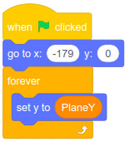
3) Add the following scripts:
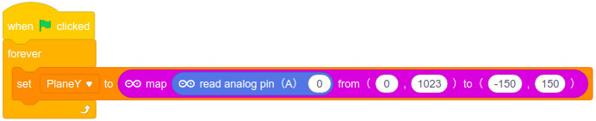
Plane sprite
Arduino Device

Challenge!

1) In the example program, the potentiometer controls the position of the plane. That makes the game too easy. Can you make it control the Y-velocity instead?

Adding Balloons

1) Add a balloon sprite

2) Connect a red LED to your Arduino. You can refer to lesson 1 for the connection diagram.

3) Add the following scripts:
Balloon sprite
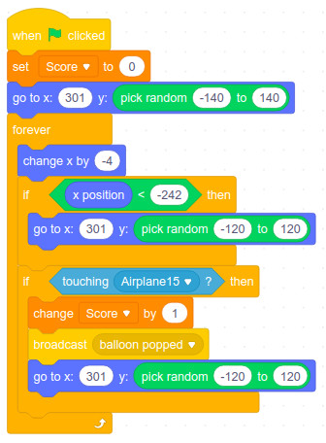
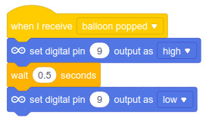
Arduino Device

Challenge!

2) Add in a Red LED and make it flash if the plane misses the balloon.

Tips
- Use a second resistor for the Red LED.
- Two LEDs cannot share a resistor, unless the LEDs are exactly the same voltage

Adding Clouds

The cloud script is the same as the balloon, but without detecting contact with the plane.

Challenge!

3) A parallax effect can simulate depth and improve the animation quality of your game. Read up on “parallax effect in games” and try to implement it on your clouds

Discuss!

How can you use games and the Arduino to encourage people to exercise more?

_________________________________________________________________________

_________________________________________________________________________

_________________________________________________________________________

_________________________________________________________________________

_________________________________________________________________________

_________________________________________________________________________

