Name: |  | Class:

Lesson 10 (Protoype / Test)

Slides – https://a9i.sg/huayi
mBlock – https://ide.mblock.cc (start mLink too!)

Design Thinking

Empathize
Define
Ideate
Prototype
Test

Iterate

Start Creating Solution
- Review Problem Statement & Solution Design
- Work with your team to fabricate your device
- Test early & often

Keep In Mind
- User is the most important member of the design team
- If they are not around, empathize & test from their viewpoint
- Be open to criticism, feedback and creative destruction
- Time to make hard decisions – what can realistically be finished in time?

Shopping List
- Sensors, Actuators, Fabrication Materials, Tools, and more...
- The earlier you identify what you’ll need, the more likely you will get it in time for your prototyping and testing
- Don’t ask for everything, but guess what you’ll need most likely

ALP Project (Shopping List)
Make sure to keep this; you’ll need to include it in your ALP report.

Category  (Sensor, Actuator, Fab, Tool, Other) | Item Desctiption, Amount, if relevant

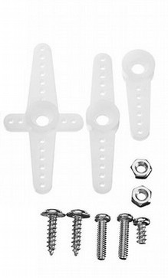
Servo Motor
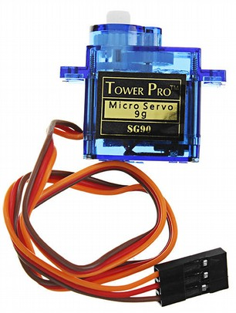

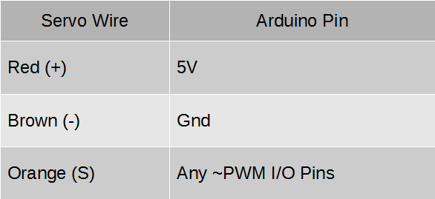
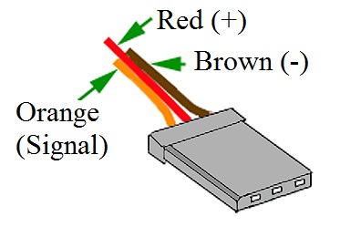

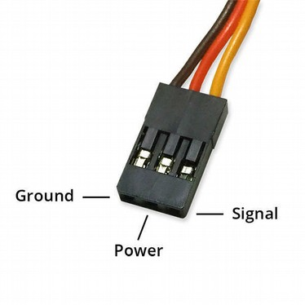
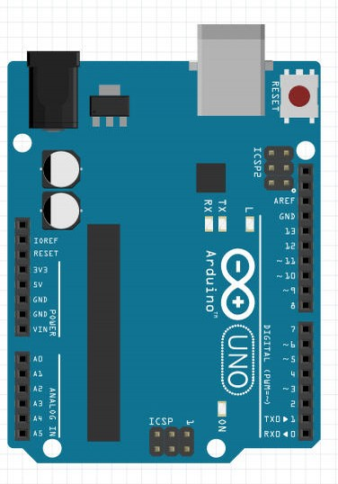

Use the special Servo Pin blocks to set angle (0-180º):


LCD
See - https://www.arduino.cc/en/Tutorial/HelloWorld

Use same 330 ohm resistor…
For our Potentiometer – wiring slightly different than shown...

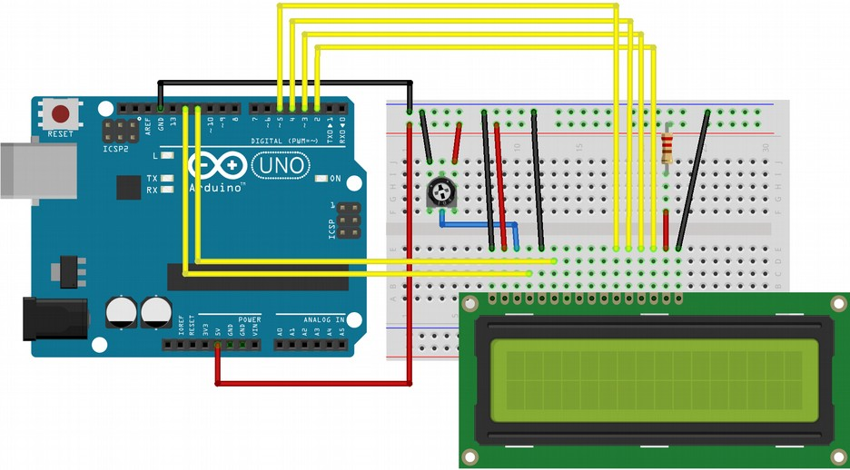

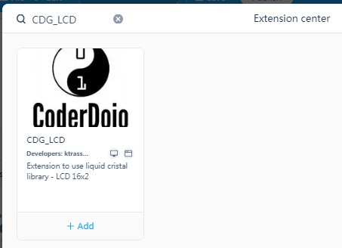
CodeDojo CDG_LCD Extension



