Name: |  | Class:

Lesson 9 (Review / Iterate)

Slides – https://a9i.sg/huayi
mBlock – https://ide.mblock.cc (start mLink too!)

Design Thinking

Empathize
Define
Ideate
Prototype
Test

Refine

Review / Checkpoint
- Review Idea
- Review Problem Statement
- Work with your team to refine what you already have

Keep In Mind
- User is the most important member of the design team
- If they are not around, empathize and think from their viewpoint
- Be open to criticism, feedback and creative destruction
- Don’t mind what’s hard to do at this stage, only what’s the best solution

Lite Project Management
- Break project into components (e.g. artwork, code, electronics, packaging, report)
- Break component into steps/tasks
- Set hard dates working back from project completion date
- Don’t exaggerate your ability, or the complexity of each item
ALP Project (Management)
Make sure to keep this; you’ll need to include it in your ALP report.

ID | Description | Completion Date | Dependency (ID)

Temperatuer Sensor
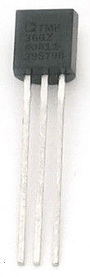
Pins Connections

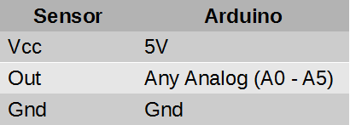
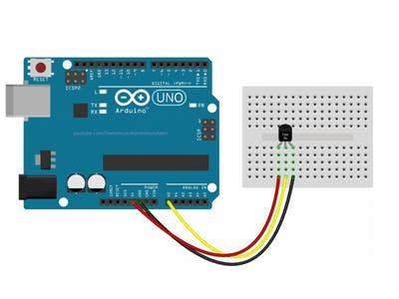

Vcc
Gnd

Out

Reading Analog & Converting to Voltage (mV)
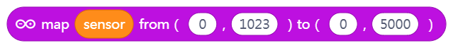

Converting Voltage to Temperature (°C):
Temperature = (mVoltage – 500mV) / 10
(broadcast result or save in a variable)

Showing temperature:
- Sprite Says (º36), like a speech bubble
- Or show in some other way (Variable monitor)

Activity
Record lowest temperature measured (of room, inside fist, etc) ______ ºC
Record highest temperature measured (of room/inside fist, etc) ______ ºC

Heat Alarm
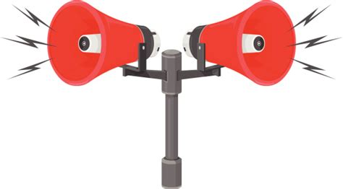
Add On-Screen Alert!

- Choose a threshold.
- Show a Siren Sprite if Too Hot!

Add Alarm!

- Choose a threshold
- Activate buzzer to alarm users

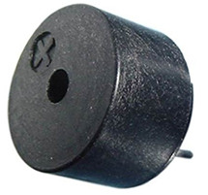

Buzzer | Arduino
+ | Any I/O (Pin 2 to 12)
- | Gnd

