3D Design and Printing

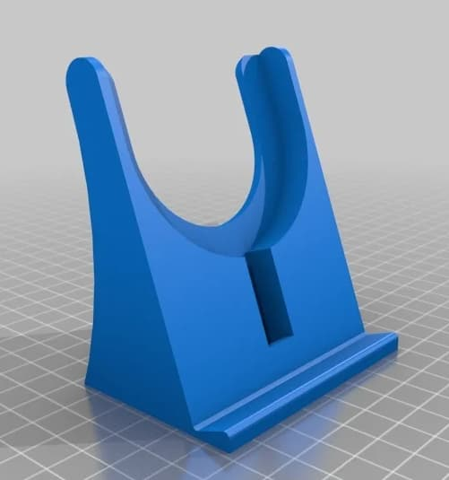
Chapter 1

Scope
- Design, Slice, Print
- Creating a Part
- Sketching and Dimensions
- Extrusion and Hole
- Exporting to Mesh
1.1 | Introductions

About this Course
This course will prepare you in designing a part for 3D printing, with an emphasis on engineering applications. In this course, we will be using the Onshape (http://onshape.com) 3D mechanical CAD software, and you are expected to register a free account prior to starting this course.

What this Course is NOT
This course will NOT prepare you for artistic 3D modelling. While you can certainly use Onshape to design a 3D alien or pokemon model, it is not well suited for such purposes.

This course also does NOT cover all the common operations in engineering CAD. Important topics such as producing engineering drawings and parts assemblies are excluded, as they are not required for 3D printing.

About A Posteriori
A Posteriori is a provider of STEM education services in Singapore. We believe in open sharing of knowledge, and you can find this course and many more on our website (https://aposteriori.com.sg)
1.2 | Design, Slice, Print

Overview
The 3D design and printing process, consists of 3 main steps:

- Design
- Slice
- Print
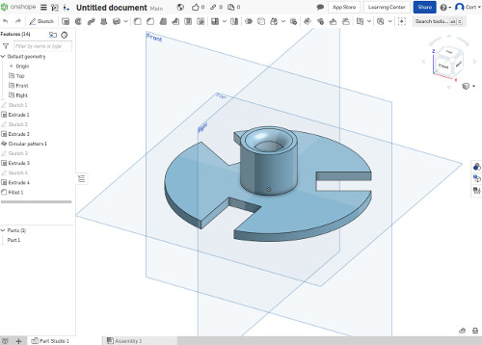Designing with the Onshape software

Design
In this step, we will create the 3D model using an engineering CAD software. For this course, we’ll be using the Onshape software (http://onshape.com). A free subscription is available for Onshape, and the software runs within your web-browser, so no installations are required.

When designing our 3D model, we will draw the model, set the dimensions, and export a mesh file.
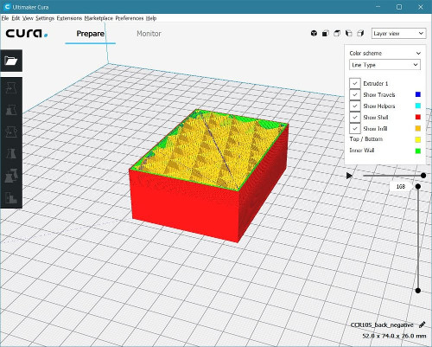Slicing with the Cura software

Slice
Slicing is the process of turning the 3D mesh file into a set of instructions for the 3D printer. These instructions are typically in gcode format.

During the slicing process, we will set important printing parameters such as print quality, whether the object is solid or hollow, and the nozzle and bed temperature. We cannot however, change the design of the model. We’ll typically be using Cura (https://ultimaker.com/software/ultimaker-cura) for this.

Print
Here’s where we perfom the actual printing of the object. We will transfer the gcode file to the 3D printer using an SDcard. If your printer is already well calibrated and prepared, you shouldn’t need to do more than click print.

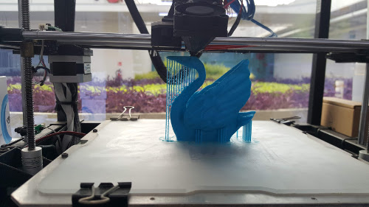Printing on a Rigidbot 3D printer
1.3 | Creating a Part

Part Design Process
In 3D design, a part is the smallest piece that is made of a single material. For example...

- A spoon is a part. It is made of one single material (steel) and cannot be separated into smaller pieces.
- A pair of scissors is not a part. It is made of multiple materials (steel for the blade, plastic for the handle) and can be separated.

The process of creating a part, consists of...

- Surface. Select a surface to draw on.
- Sketch. Draw a 2D sketch.
- Dimension. Set the dimensions for the sketch.
- Extrude. Turn the 2D sketch into 3D.

Getting Started
From here on, we’ll be using the Onshape software. Open the Onshape website and login. You should see a screen like this...

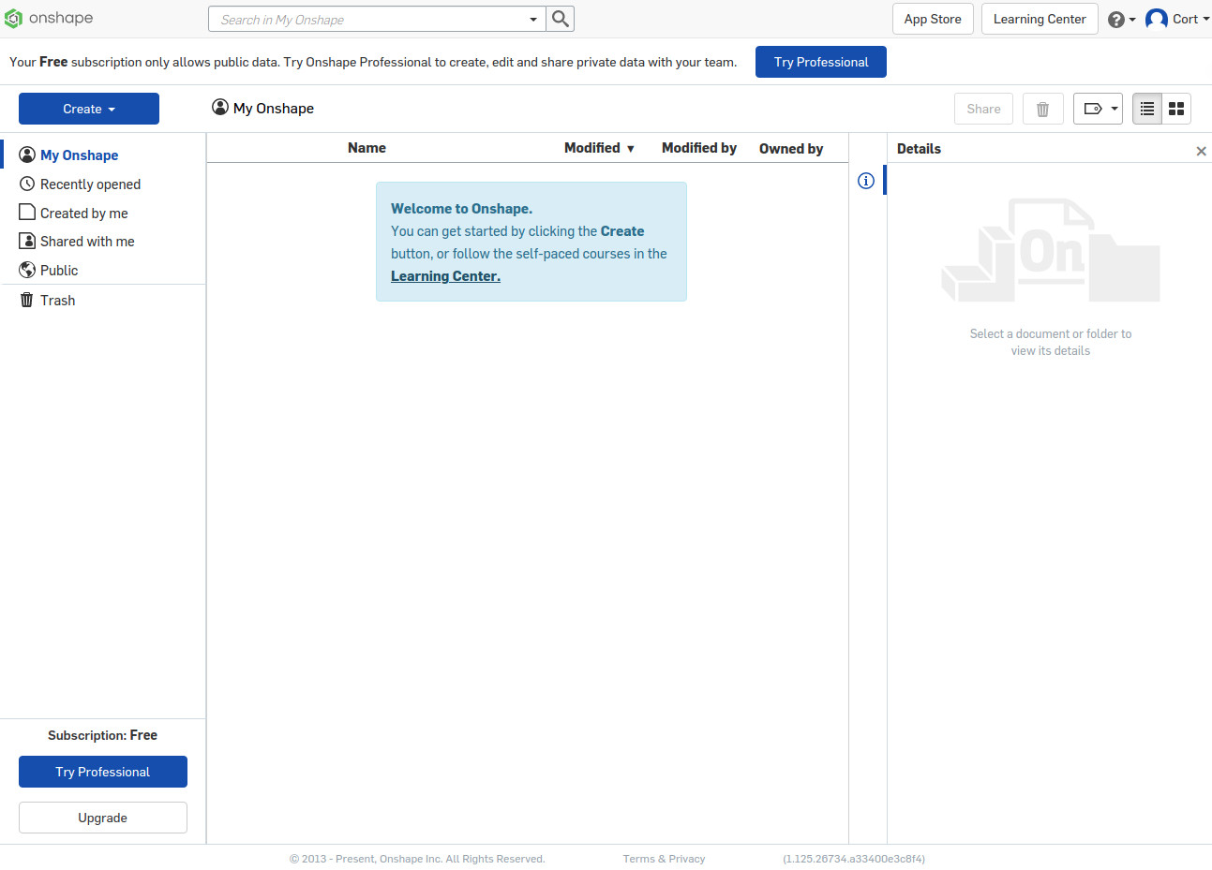Onshape Documents page
If you have created any designs, you’ll see them here. Go ahead and click...

.. select “Document...”, and give it a name (eg. “Exercise 1”). You should now be in the Part Studio, which looks like this...

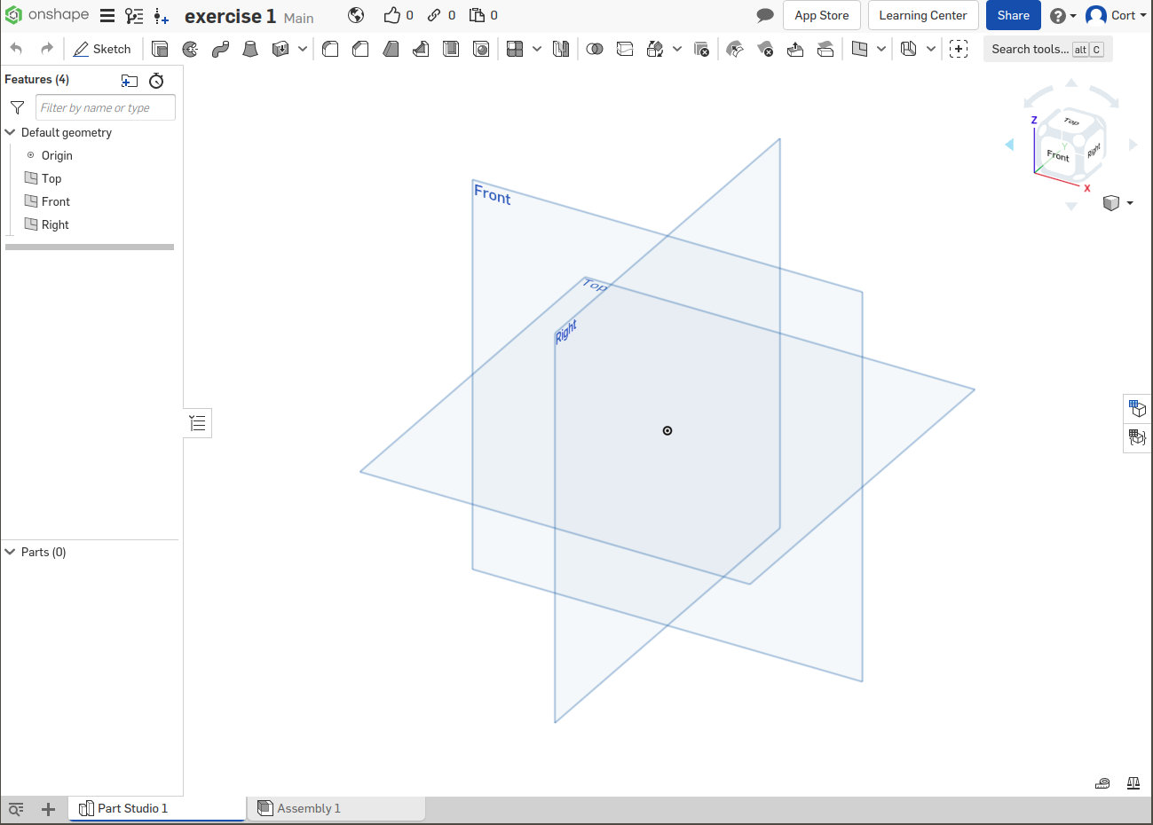Part Studio
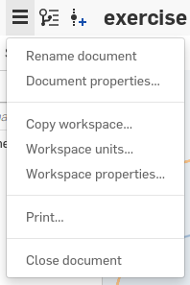
Before doing anything else, we want to make sure our units are set to millimeters. Click on the Document menu (...the 3 horizontal bars), and select “Workspace units...”. Set it to millimeters then click the green tick.

Selecting a Surface
Before we can sketch our design, we need to start by selecting a surface to sketch on. There are 3 default planes available for us to select (Front, Right, Top). It doesn’t matter much which one you choose. For this exercise, I’m going to choose Top, but you can pick whichever you like.

Click on the surface to select it (...it’ll turn orange), then click...
You’re now in the sketch mode, and the tool bar will change to show the sketch tools...

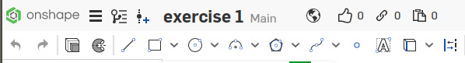Sketch tools
Go ahead and hover your mouse cursor over the icons to see a description of what they do. Don’t worry if you don’t understand it yet. We’ll be mainly using Lines, Rectangles, Circle, and Arc, and we’ll show you how to use them in the later steps.

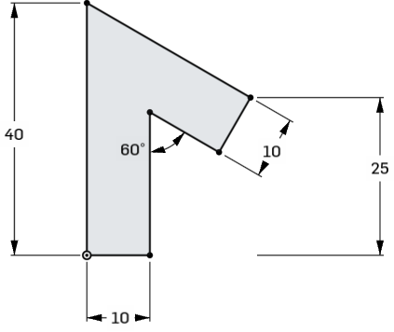
Sketching
For this first exercise, we’ll be creating this shape...

Before you start. Press “n” to rotate the view. This is not a must, but it’s a lot harder to draw if you’re viewing the surface at an angle.

Click on the line button...

...then click and release the left mouse button at the origin ( ...the dot at the center), that will start drawing the first line beginning from the origin.

Continue to click and release the button again at each of the points, but as you do so, pay attention to the symbols that appears. Some of the symbols you should see are...

The line will be perfectly vertical, or is vertically aligned to something (highlighted in orange).
The line will be perfectly horizontal, or is horizontally aligned to something (highlighted in orange).
This line will be at right angle to the previous line, or to the highlighted line.
This line will be parallel to the highlighted line.

There are more symbols that may appear, but these are fairy common. Don’t worry if you miss one or two of these, you can add them back later.

Tips: When sketching, you don’t have to worry about the length or size of each line. We’ll take care of that in the next step.

Dimensions
After you are done sketching, you’ll notice that some of the lines and points are blue. This means that those lines or points can still move around, as we haven’t set enough dimensions or conditions to prevent them from doing so. We refer this type of sketch as “under-defined”.

Click on the dimensions button...

...then click on the drawing to set dimensions. You can...

- Click on a line to set its length
- Click on two lines to set the angle between them
- Click on two points to set the distance between them
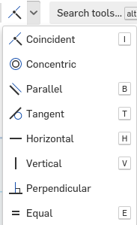
You can also click on the constraints button to set constraints on the sketch. For example, you use the “Perpendicular” constraint to force two lines to be at right angle, or the “Equal” constraint to force two lines to have the same length.

Once you have set sufficient dimensions and constraints, there should be no blue lines or points remaining. The sketch is now referred to as “fully defined”.

While the software don’t strictly require us to fully defined every part, it is considered good engineering design practice to always do so.

Extrude
Now that we are done with the sketch, click the green tick...

...to complete the sketch.
Select the sketch from the “Features” list...
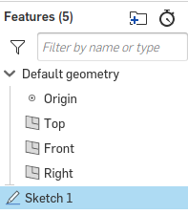
...and click the extrude button...
This will turn your 2D sketch into a 3D shape. If you can’t see the 3D shape, try rotating the view around by clicking and dragging with the right mouse button.
Set the “Depth” to 20mm, then click the green flag to complete the extrude.
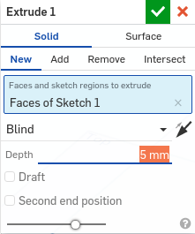

Hole
Beside extruding a sketch to produce a solid, we can also use a sketch to remove materials.
We’ll start by creating a new sketch. This time, we’ll select one of the faces on our part as the sketch surface. Select this face by clicking on it (...it will turn orange)...
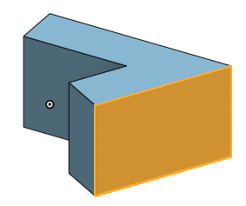
Click the “Sketch” button, then press “n” to rotate the view.
Click on the “Center point circle” icon...
Bring the cursor to the center of the right most line. You should see a small orange box appear on the line (...the box represents the center point of the line). Carefully move the cursor to the left, you should see a dotted line extend outwards.
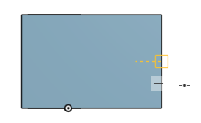
Click to start drawing the circle and click again to complete the circle. Set the following dimensions.
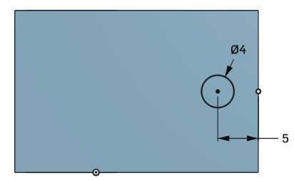
When done, hit the green tick to complete the sketch.
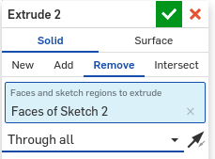
Select the last sketch, then click on the “Extrude” button. This time, we’ll select “Remove”. This will set it to remove materials instead of adding it. We’ll set the depth to “Through all”, so that it will cut all the way through.

Export
There is no need to save, Onshape automatically saves your work for you. But to be able to slice the model for 3D printing, you’ll need to export the model into a mesh file format.
Select your part from the parts list...
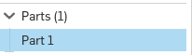
Right click on the part, then select “Export...”. Make sure that the format is STL or OBJ, and the units are in meters, then click “Ok”.
After a few seconds, your browser should download a .stl or .obj file, that contains your model in a mesh format.
Mesh files
- Typically in STL or OBJ format
- Can be sliced (...producing gcode)
- Not suitable for editing (...use the copy automatically saved in Onshape instead)
To return to the documents page, click on the Onshape logo...
1.4 | Exercise 2

- Create -> Document...
- Set name as “Exercise 2”
- Select Surface
  - Select the “Top” plane
- Sketch
  - Click the Sketch button
  - Press “n” to rotate the view
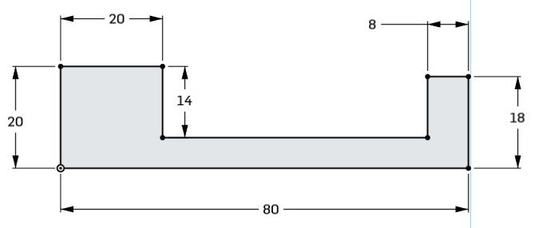
  - Draw and dimension the following
- Extrude
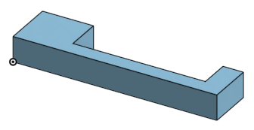
  - Extrude with a depth of 10mm
- Sketch
  - Select the top face of the part
  - Press “n” to rotate the view
  - Draw and dimension the following circle
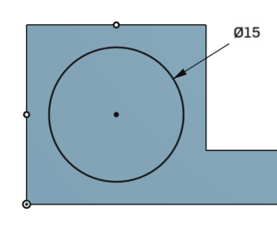
  - Take note of the two center point constraints.
- Extrude
  - Extrude with a depth of 2mm.
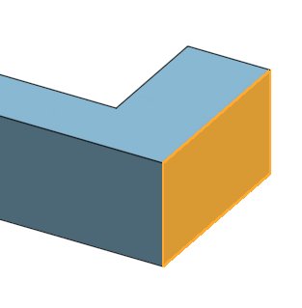
- Sketch
  - Select the following face...
  - Press “n” to rotate the view
  - Draw and dimension the following...
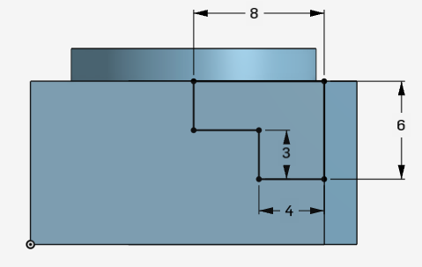
- Extrude
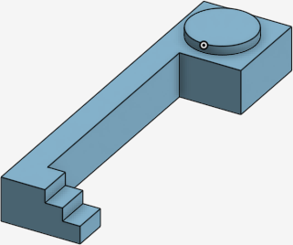
  - Remove materials with depth set to “Up to next”.
- Export and close

1.5 | Exercise 3

Design a Stationary Holder
Design your own stationary holder. I’ve provided a picture of mine here for your reference, but dimensions are not provided (...choose your own). You can also ignore mine and create your own design.

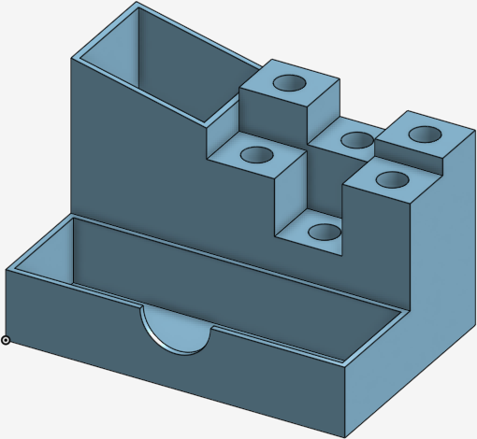

Computer Aided Design
Try softwares like Blender instead
There are many free lessons on the Onshape websites, so you can learn these topics from there yourself.
Gcode is a standard format that’s used by not just most 3D printers, but also many other industrial machines. Some 3D printer manufacturers wants to be “special” and use a different format. We try not to buy their printers.
...and wait. 3D printing is slow.

