3D Design and Printing

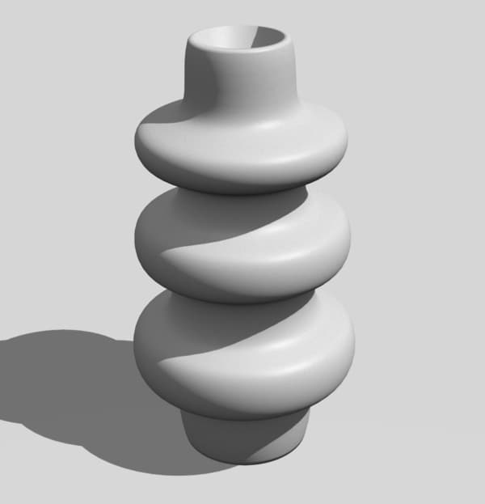
Chapter 2

Scope
- Creating a Part with Revolve
- Fillet and Chamfer
2.1 | Revolve

Introduction to Revolve
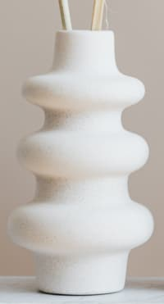Can't be made with extrude, easy to do with revolve
In the previous lesson, we learned to create parts by...

- Drawing a 2D shape
- Extruding the 2D shape to form a solid

This works well for many shapes, but what if we want to create a shape like a vase? In cases like this, the normal extrude will not be suitable, instead, we will need to use the revolve feature to create the solid shape.

The process is very similar, we will start by drawing a 2D shape, then apply the revolve to create the 3D solid. While the normal extrude will extend the 2D shape outwards in one direction, the revolve tool will instead extend it out in a circle, centered about an axis that you select.

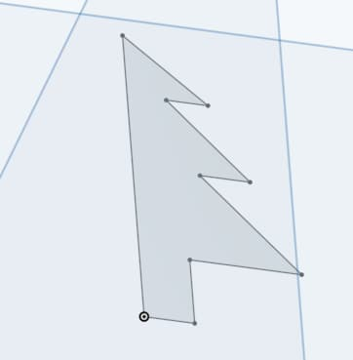From 2D drawing...
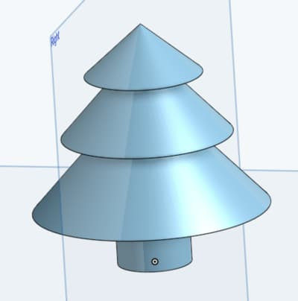...to 3D shape using revolve

Part Design Process
The part design process is the same, but instead of doing an extrude in step 4, we’ll be doing a revolve instead.

- Surface. Select a surface to draw on.
- Sketch. Draw a 2D sketch.
- Dimension. Set the dimensions for the sketch.
- Revolve. Turn the 2D sketch into 3D.

Setting Default Units
From here on, we’ll be using the Onshape software. Open the Onshape website and login.

It can get tedious setting the units every time, so let’s set the default to millimeters. Click on your name at the top right hand corner, then select “My account”. Next, go to preferences, set your units to millimeters, and click “Save changes”.
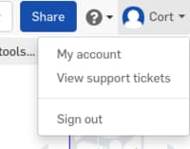
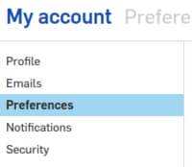

When done, click on the Onshape logo on the top left to return to the home screen.

New Design
We’ll be creating a new design. Go ahead and click...

.. select “Document...”, and give it a name (eg. “Revolve Exercise 1”). You should now be in the Part Studio, which looks like this...

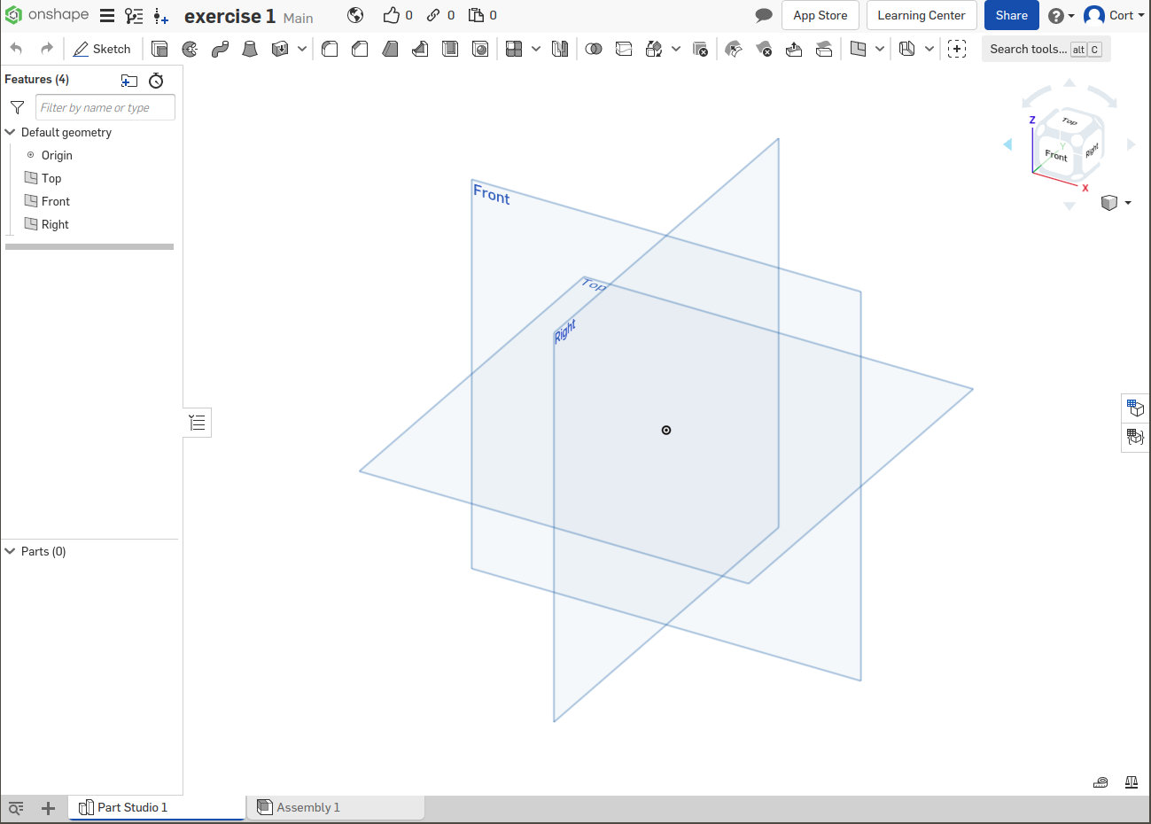Part Studio

Selecting a Surface
As before, we’ll need to start by selecting a surface to sketch on. There are 3 default planes available for us to select (Front, Right, Top). It doesn’t matter much which one you choose. For this exercise, I’m going to choose Front, but you can pick whichever you like.

Click on the surface to select it (...it’ll turn orange), then click...
You’re now in the sketch mode, and the tool bar will change to show the sketch tools...

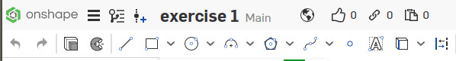Sketch tools

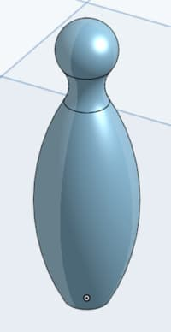
Sketching
For this shape, we’ll be making use of a lot of arcs.

There are 4 different types of arcs that you can use. Besides the “conic” arc which is a little special, the rest of them are interchangeable; you can draw one type and change the constraints to make it behave like another. Choosing the right type of arc can help you work faster, but don’t worry if you choose the wrong one.
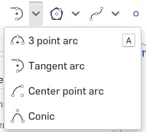
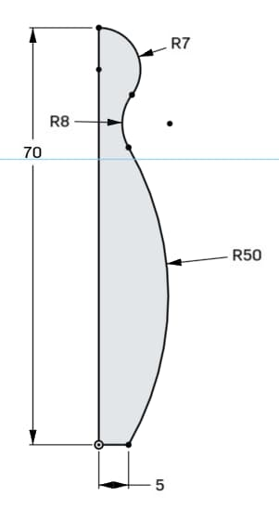
Before you start. Press “n” to rotate the view. This is not a must, but it’s a lot harder to draw if you’re viewing the surface at an angle.

Tips: Always try to start your drawing from the origin.
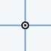The dot is the origin

Important: The 3 arcs are tangent to each other. This basically means that there isn’t a sharp angle at the point where they join. Such relationships are often implied in engineering drawing; watch out for them.

Recommended steps (...you don’t have to follow these, but it’s easier this way):

- Start by drawing the 5mm horizontal line. Start from the origin.

- Draw the 70mm vertical line.

- Use the “Center point arc” to draw the top most arc (R7: radius is 7mm).
  - First click should be on the vertical line, that will set the center point.
  - Second click should be on the top tip of the vertical line.
  - Place the last click roughly where you see it in the picture above.

- Use the “3 point arc” to draw the bottom most arc (R50: radius is 50mm).
  - First click should be on the end of the horizontal line.
  - Place the second click roughly where it joins to the R8 arc.
  - Position the last click such that the curve roughly matches what you see above.

- Use the “Tangent arc” to draw the middle arc (R8: radius is 8mm).
  - Place the first click on the end of the R7 arc. This will automatically set a tangent constraint with it.
  - Place the second click on the end of the R50 arc. This will NOT set a tangent constraint; you’ll need to set it manually.

- Select both the R8 and R50 arcs, then click the tangent button to set a tangent constraint.
- Select the two endpoints of the R8 arc and set a vertical constraint.

Dimensions
After you are done sketching, set the dimensions accordingly.
Click on the dimensions button...

...then click on the drawing to set dimensions.

- Click on the two lines to set their length
- Click on the three arcs to set their radius

If you have done all of these correctly, there should be no blue lines or points remaining. The sketch is now “fully defined”.

If there are still some blue lines remaining, check for these common errors...

- Make sure at least one of the points is on the origin
- Check that all 3 arcs are tangent to each other; if you hover your mouse cursor over the middle R8 arc, you should see 2 tangent symbols appear. If you only see one (...or none), then you’re missing a tangent constraint.

Revolve
Now that we are done with the sketch, click the green tick...

...to complete the sketch.

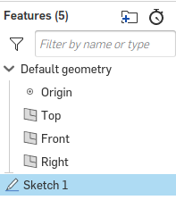
Select the sketch from the “Features” list...

...and click the revolve button...

For the revolve to work, you’ll need to tell it which axis to revolve around. First click the “Revolve axis” field, then click on the vertical line (70mm).

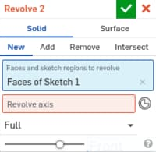
This will turn your 2D sketch into a 3D shape.

By default, the revolve is set to “Full”. Feel free to play around with the settings and see what happens when you...

- Change the revolve axis to the horizontal line
- Change the revolve setting from “Full” to “One Direction” and change the angle.

Revolve Around Centerline
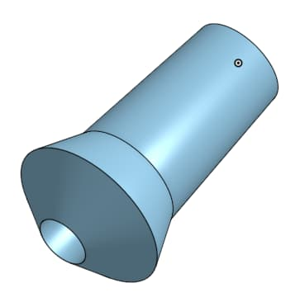
Sometimes we may need to create a revolve that is hollow in the center, such as the nozzle on the right.

In such cases, we will not have a suitable line on our 2D shape to select as the revolve axis. To solve this, we can add a centerline, which is a type of construction line.

Constructions line are lines which are useful for our drawing, but are not actually part of the object. When carrying out an extrude or revolve, the Onshape software will ignore them.

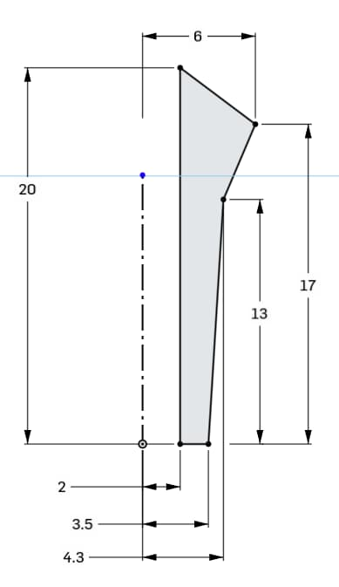
Start a new document, and draw the sketch on the right.

The centerline is the line with dots and dashes. To create a centerline, first draw a normal line then select the line and click the “Construction” button.

Once you are done with sketching and dimensioning, perform the revolve and select the centerline as the revolve axis.
2.2 | Fillet and Chamfer

Sharp Corners are (...usually) Bad
Sharp corners are often undesirable in our design, because they...

- ...concentrate stress, making parts more likely to break
- ...feel uncomfortable when we hold it
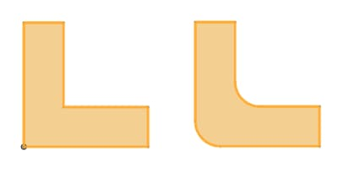
- ...looks ugly (...sometimes, not always)
Bad: Stress concentration
Better

Fillets
While we can manually draw in the rounded corners that you see in the above example, it can be very tedious to do so, especially when there are a lot of corners in your design. To help with this, most 3D CAD software provides a fillet feature to help you add in rounded corners.
We’ll practice on the previous nozzle example.
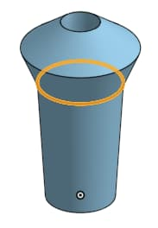
- Start by selecting the corner marked in orange on the right.
- Next, click the “Fillet” button.
- In the fillet settings, change the fillet radius to 10mm (Try different values and see the effects).

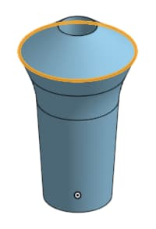
- Select the next corner (...marked in orange).
- Again, click the “Fillet” button. This time, set the fillet radius to 1mm (Feel free to experiment with different values).
- Click the green tick to complete the fillet. The object should now look like the image below.
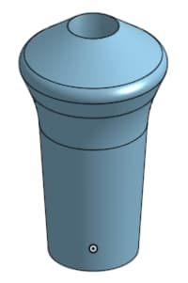Fillets completed
Fillet (meaning: rounded corner) is an English word, and is pronounced “fill-it”.

Fillet / Filet (meaning: thin slice of meat) originates from French, and is pronounced “filay”.

Same spelling, different pronouciation.

Chamfers
Chamfers are similar to fillets, but instead of adding a curve, it adds a flat surface.
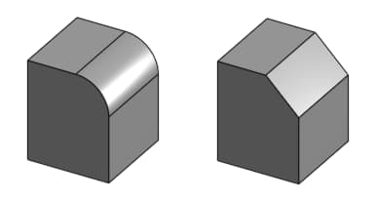Fillets (Left) vs Chamfer (Right)
Fillets are better for reducing stress and often looks better, but chamfers can be useful in some cases too.
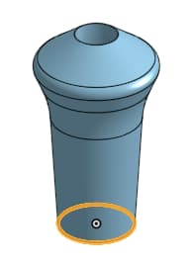
The nozzle that we have created is meant to connect to a hose. To make it easier to plug in the hose, we’ll add a chamfer to the bottom.
- Select the corner marked in orange.

- Click the “Chamfer” button.

- You should see that the edge in the chamfer settings is marked in red. This is because there is not enough materials to create a 5mm chamfer there.
- Change the chamfer distance to 1mm. The text should now change to black.
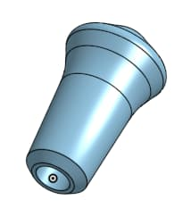
- Click the green tick to complete the chamfer. The object should now look like this...
2.3 | Exercise 4

For this exercise, we’ll be creating an angled nozzle that you can use with your hand sanitizer dispenser.

- Create -> Document...
- Set name as “Exercise 4”
- Select Surface
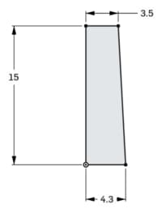
  - Select the “Top” plane
- Sketch
  - Click the Sketch button
  - Press “n” to rotate the view
  - Draw and dimension the sketch on the right

- Revolve
  - Revolve the sketch, using the vertical line as the axis
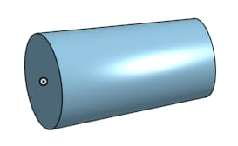
  - This is where our hose will connect

- Sketch
  - Select the larger end of the cylinder (...side with 4.3mm radius)
  - Press “n” to rotate the view
  - Draw and dimension the following
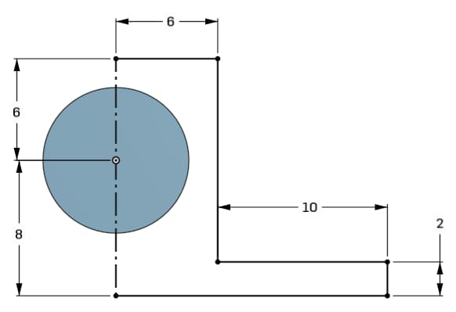
  - Note that the long vertical line is a construction line.
  - Select the construction line, then click the “Mirror” button. You’ll be asked to select entities to be mirrored.
  - Select all the lines except the construction line. Your sketch should now look like this
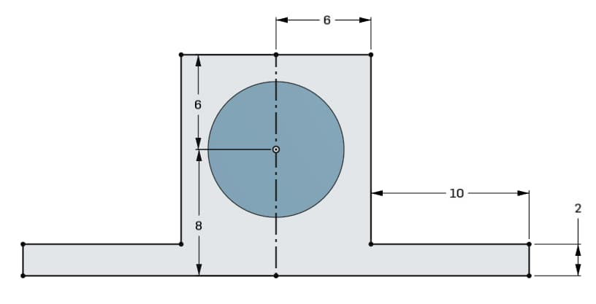
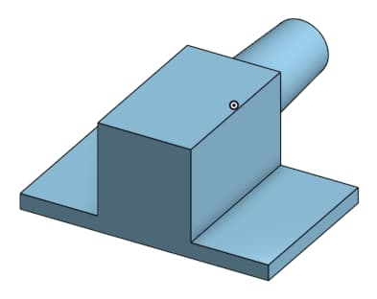
- Extrude
  - Extrude with a depth of 20mm

- Sketch
  - Select the bottom face
  - Press “n” to rotate the view
  - Draw and dimension the following...
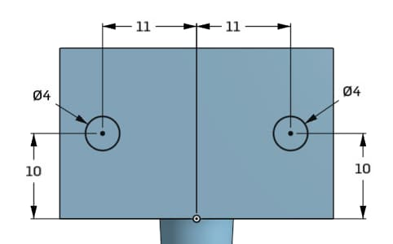
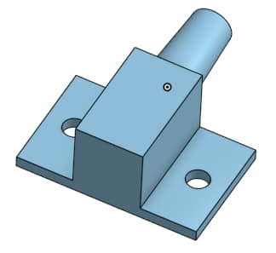
- Extrude
  - Remove materials with depth set to “Up to next”.
- Sketch
  - Select the bottom surface again
  - Press “n” to rotate the view
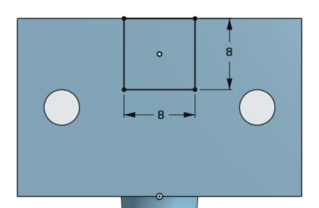
  - Draw and dimension the following...
- Extrude
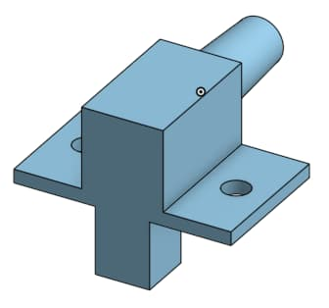
  - Extrude with a depth of 10mm.
  - This will be our nozzle
- Sketch
  - Select the end of the cylinder
  - Press “n” to rotate the view
  - Draw and dimension the following...
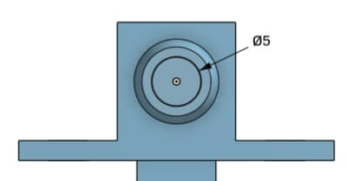
- Extrude
  - Remove materials with depth set to 33.5mm
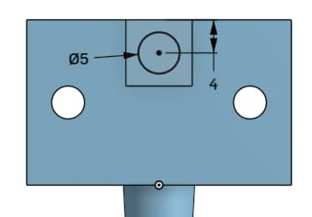
- Sketch
  - Select the bottom of the nozzle
  - Press “n” to rotate the view
  - Draw and dimension the following...

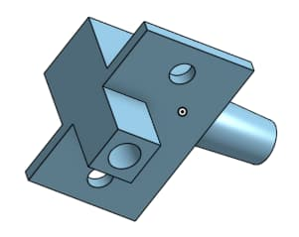
- Extrude
  - Remove materials with depth set to 18mm

- Fillet and Chamfer
  - Add fillets and chamfers to make the final object look like the following images.
  - All fillets are 2mm radius, and all chamfers are 1mm distance
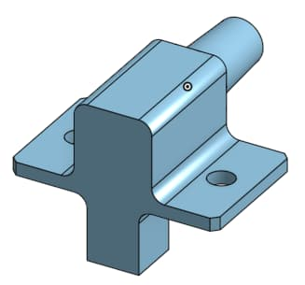
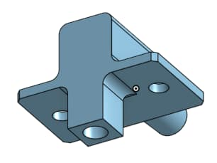
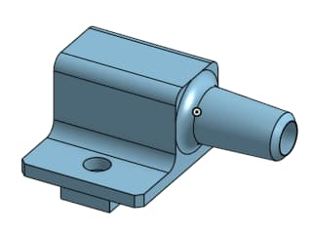
2.4 | Exercise 5

Design a Vase
Design your own vase. I’ve provided some pictures of mine here for your reference, but you should create your own design.



