3D Design and Printing

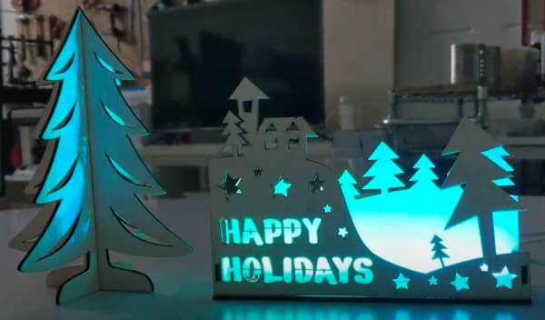
Chapter A

Scope
- Prepare for Laser Cutting
4.1 | Prepare for Laser Cutting

Introduction
Laser cutting can be much faster than other fabrication methods, but can only produce flat parts. By adding pins (aka tabs / fingers) to your design, you can create parts that can be easily glued together to create strong 3D objects.
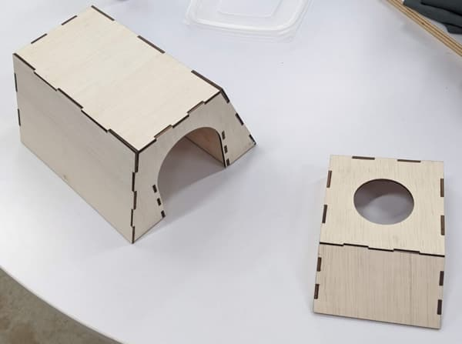
Before starting on this chapter, be sure to complete Chapter 1. You will minimally need to know how to sketch and extrude before you start.

Simple Box
For this first exercise, we’ll be creating a simple box.

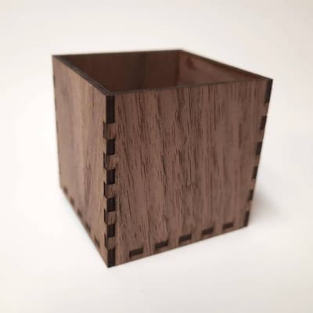

New Design
From here on, we’ll be using the Onshape software. Open the Onshape website and login. We’ll be creating a new design. Go ahead and click...

.. select “Document...”, and give it a name (eg. “Laser Cut Exercise 1”). You should now be in the Part Studio, which looks like this…

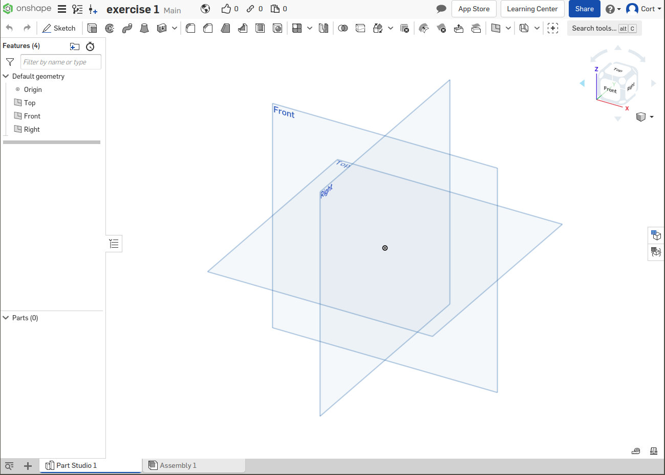Part Studio

Selecting a Surface (Back Panel)
We’ll start by creating the back of the box. As before, we’ll need to start by selecting a surface to sketch on. There are 3 default planes available for us to select (Front, Right, Top). For this exercise, I’m going to choose Front.

Click on the surface to select it (...it’ll turn orange), then click...
You’re now in the sketch mode, and the tool bar will change to show the sketch tools...

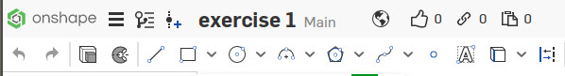Sketch tools

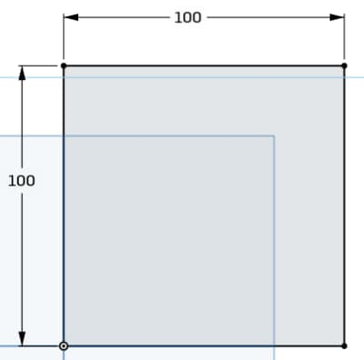
Sketching (Back Panel)
The back panel of the box is basically a square, so we’ll start with that. Draw the following using a rectangle (...any type of rectangle will do)

Dimensions (Back Panel)
After you are done sketching, set the dimensions accordingly.
Click on the Dimensions button...

...then click on the drawing to set dimensions.

- Click on the vertical line and set the length to 100mm
- Click on the horizontal line and set the length to 100mm

If you have done all of these correctly, there should be no blue lines or points remaining. The sketch is now “fully defined”.


Extrude (Back Panel)
When laser cutting, the thickness is determined by our material. For this exercise, I will assume that we are using 3mm plywood, but you should measure your actual material thickness and set it to that.
Select the sketch and click the Extrude button, and set the thickness.
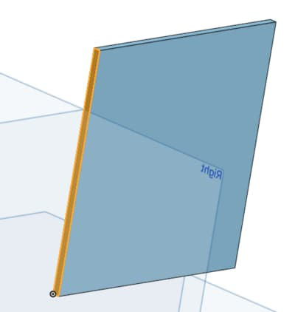

Selecting a Surface (Left panel)
Now we’ll need to add the left panel. Select the left surface of the back panel and start a new sketch.

As it is quite thin, you may need to zoom in to select it.

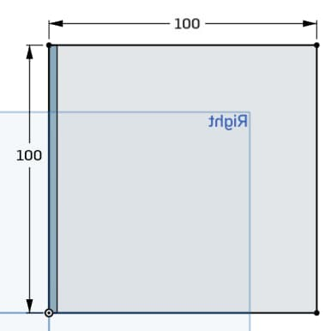
Sketch and Dimension (Left Panel)
Draw the left box as follows.

Pay close attention to where the left edge of the box is located; the box should overlap the back panel.

Extrude (Left Panel)
The extrude step is different from before. Two important differences…

- The extrusion should be a “New” part, and not an Addition to the first part.
- The new part should overlap the old part; you’ll likely need to change the extrusion direction for this.
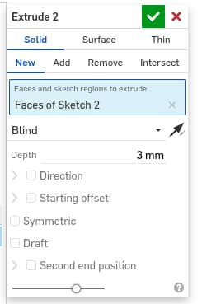
Select “New”
Click the arrow to switch extrusion direction
Set the depth to your material thickness
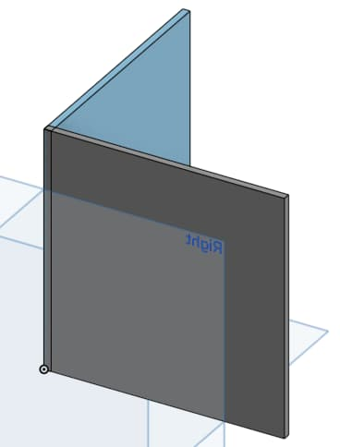
If done correctly, you should see two parts in the parts list, and the two parts should appear in different colors with a slight overlap.

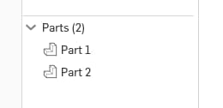

Right Panel and Front Panel
Repeat for the right and front panel. All panels are 100mm x 100mm.

If done correctly, you should now have 4 parts in your parts list, and the parts should look like this...
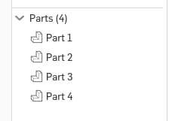
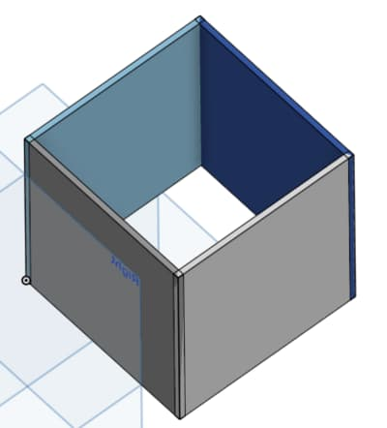

Plane (Bottom Panel)
For the bottom panel, we do not want it to be flush with the bottom of the box. It should be slightly raised (...makes it stronger). For this, we’ll need to first create a new plane before sketching.
Select the bottom surface, the click the Plane button.
Set the new plane to be 3mm from the bottom surface, and change the direction so that the new plane is inside the box.
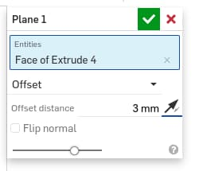
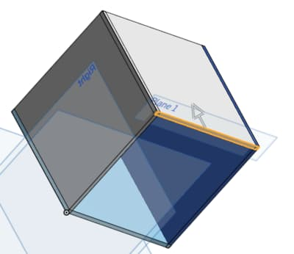

Sketch and Dimension (Bottom Panel)
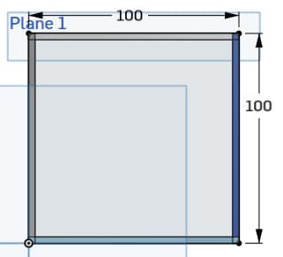
Select the new plane and start a sketch.
Draw and dimension as follows.

Extrude (Bottom Panel)
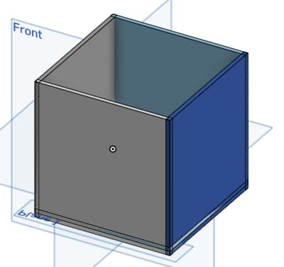
Extrude the bottom panel. Make sure it’s set as a new part and the extrude direction is upwards.

If done correctly, you should now have 5 parts and they should look like this…

Add Custom Features
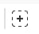
Click the “Add Custom Features” button.

Search for “featurescript laser”, then…
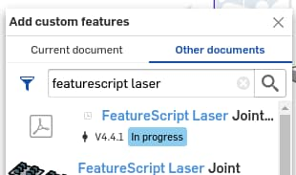
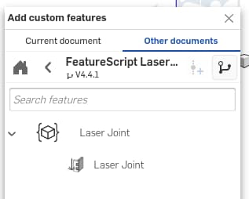
Click this…

...then this

Now search for “featurescript auto layout”, then…
Click this…

...then this

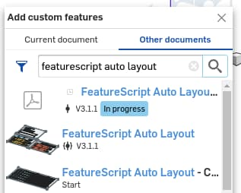
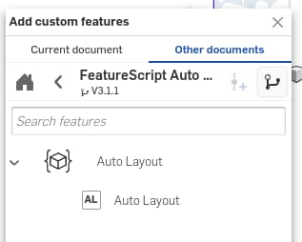
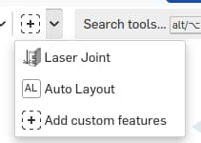
You should now see the two new features in the custom features dropdown.

Add Pins
Click the “Laser Joint” feature from the custom features dropdown.
Click this…

...then switch to
automatic

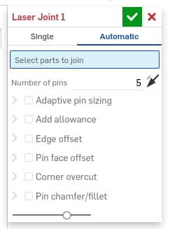

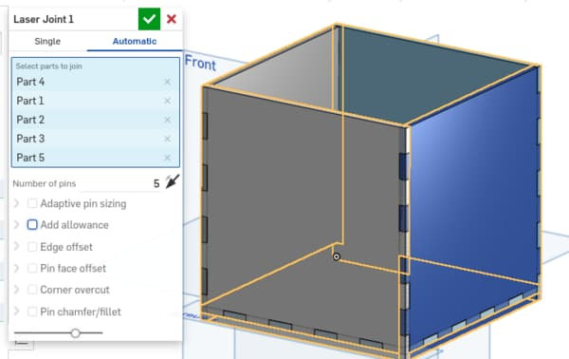
Select all the parts; you should see the pins added automatically. Adjust the number of pins as you see fit. Click the green tick when you are done.

Layout Parts
Click the “Auto Layout” feature from the custom features dropdown.
Click this…

...then set accordingly.
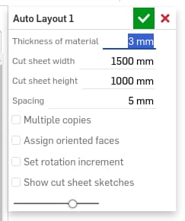

The thickness should be set according to your material thickness. The “sheet width” and “sheet height” can be set to the dimensions of your raw material, but it is not strictly necessary to do so.

Click the green tick when done.

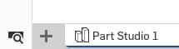
Generate Drawing
Click the “Insert new tab” button...

...then select “Create Drawing”, and set the following…

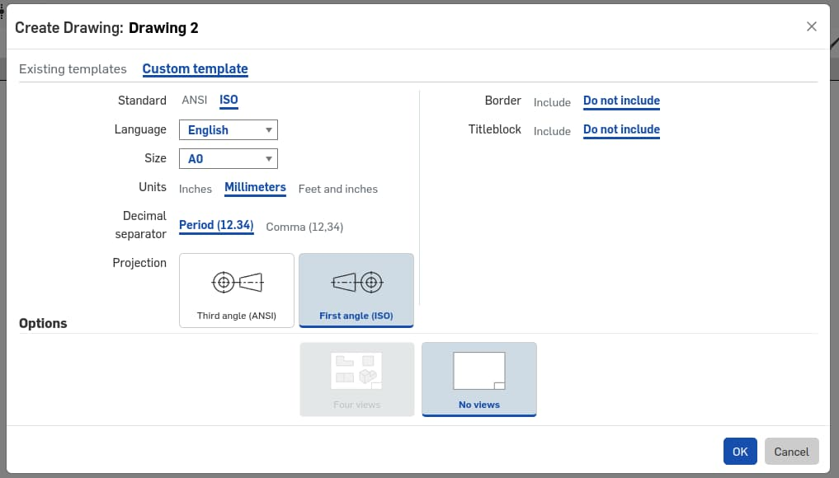
1) Custom template
2) ISO
3) Size: A0 and Millimeters
4) “Do not include” for both Border and Title Block
5) OK!
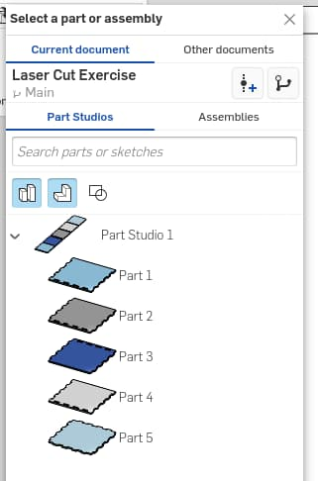
Once you are in the drawing…

Click the “Part studio” button...

...then select your part studio

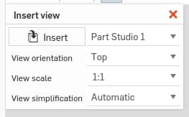
Set the “View orientation” to “Top” and “View scale” to “1:1”.

Click to place the drawing anywhere on the page (...try to fit it within the page, but if it doesn’t fit, that’s ok too), then Esc to end the insertion.

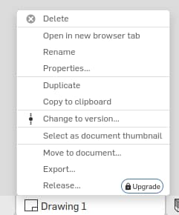
Export Drawing
Right click on the drawing tab, then select “Export”.

For the export format, you should generally choose either “SVG” or “DXF”. Both of these are usually well supported by the laser cutting software.

Note that if using SVG, you must make sure all your parts fit on the page.

Laser Cutting
The procedure for laser cutting will vary depending on the software use. A few important points to note…

- The template’s border, text area, etc. may be present in the file. Make sure you don’t use them when cutting!
- The actual parts to cut should be grouped together, making them easy to select.
- You would likely need to reposition the parts to suit your material.
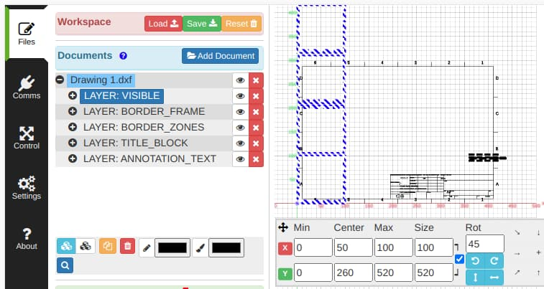DXF file loaded into Laserweb. The actual parts to cut is selected and positioned at x=0, y=0.

